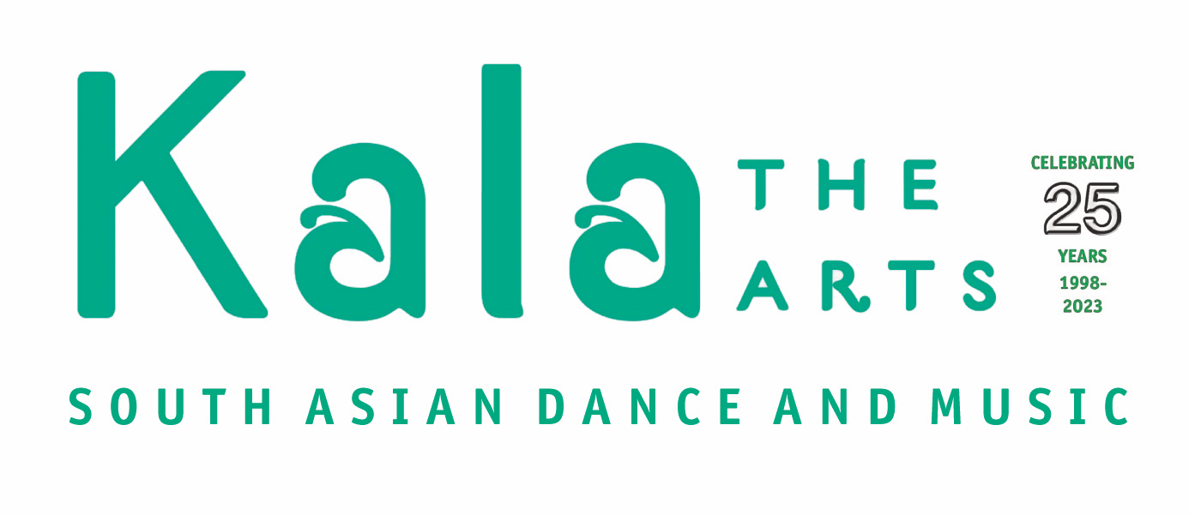

Registration Form
£25 Registration Fee is one off required on registration

Name of potential student:

Date of birth:

Parent / Guardian Name (if child):

Address:

Contact e-mail:

Telephone / Mobile Number:

Interests and experience:

Hobbies:

Signed: Date:

Interested in which class:

Odissi Dance | Kathak Dance | Tabla

Interested in:

Taking exams | Performing with Kala The Arts | Other (please specify below)

Would you be interested in being part of our mailing list, including seeing performances by Kala The Arts in these venues? Please tick and fill in email address above.
Basingstoke |  | Other Hampshire venues
Thank you for taking an interest in Kala The Arts
For office use only:

Entered onto database |  | Registration fee paid:

Kala The Arts
Basingstoke The Orchard White Hart Lane Basingstoke, Hampshire, RG21 4AF
Mobile: 07725 838419 / E-mail: Admin@kalathearts.co.uk

